E/17/153 : Part 2 – Predicting class values

1. As it shows there are 18 attributes and 81 instances in the ‘zoo_train’ dataset

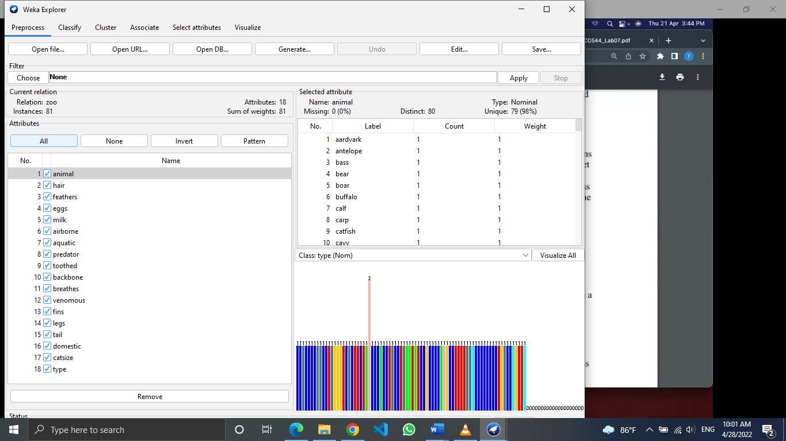

2. C4.5 decision tree with ‘Use training test’ option

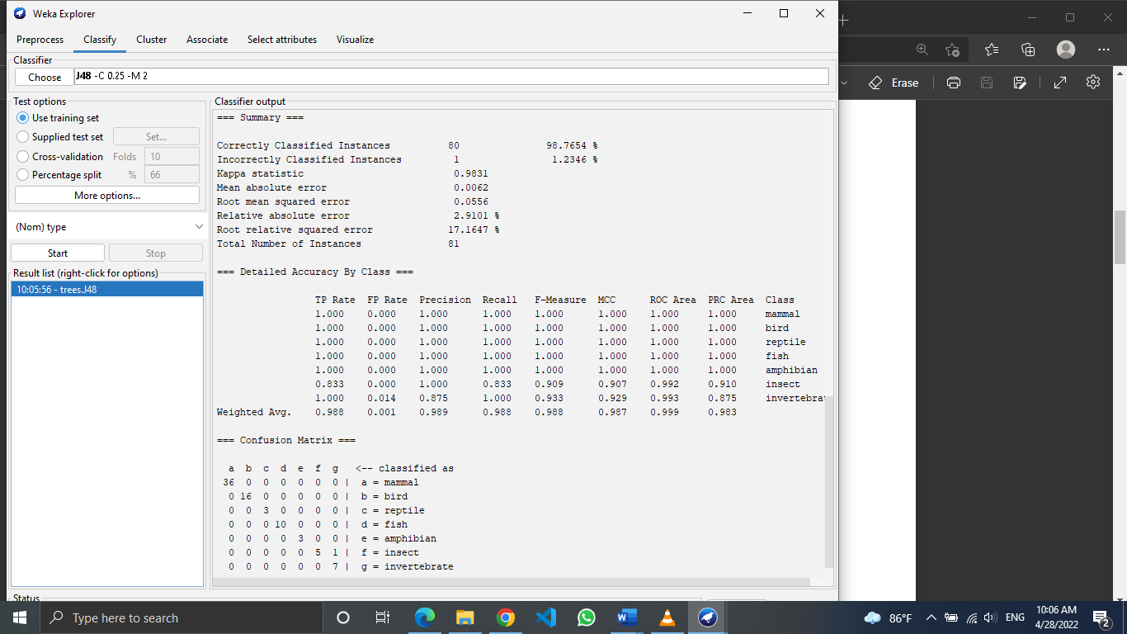

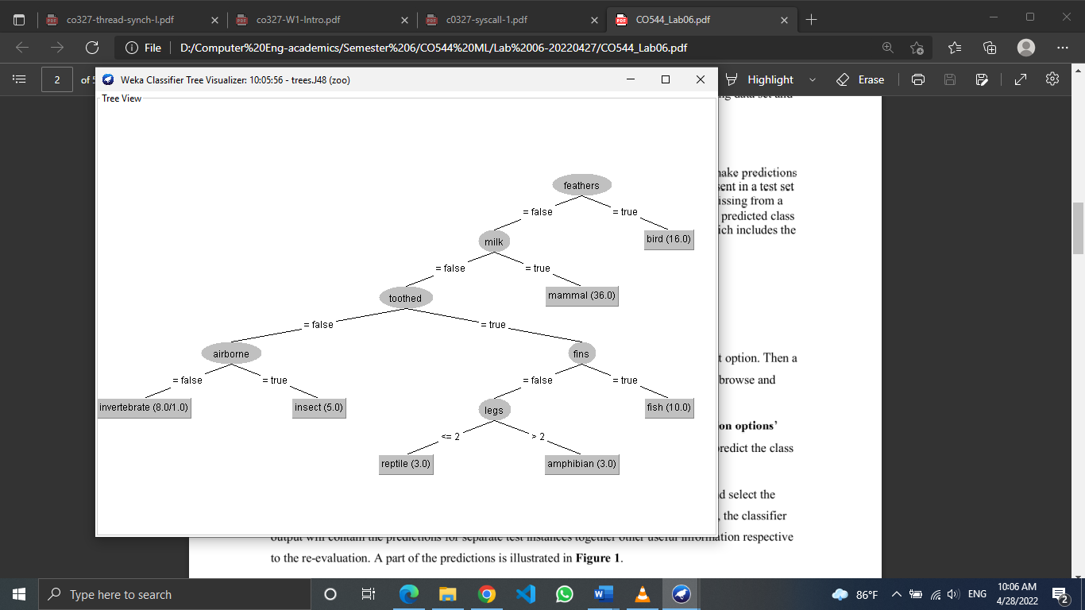

3. C4.5 decision tree with ‘Supplied test set’ option

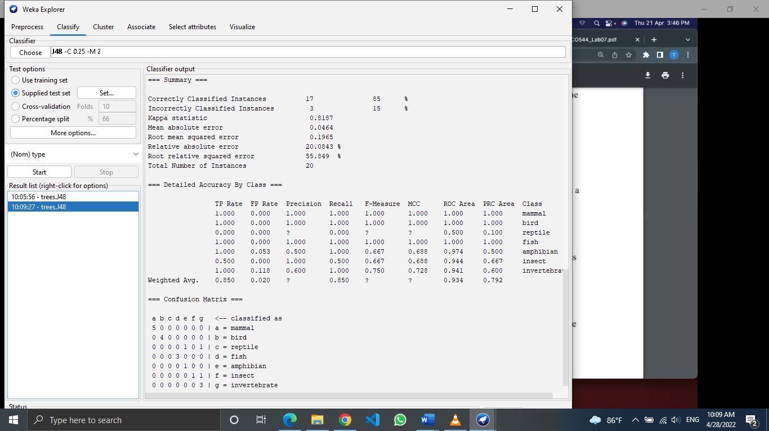

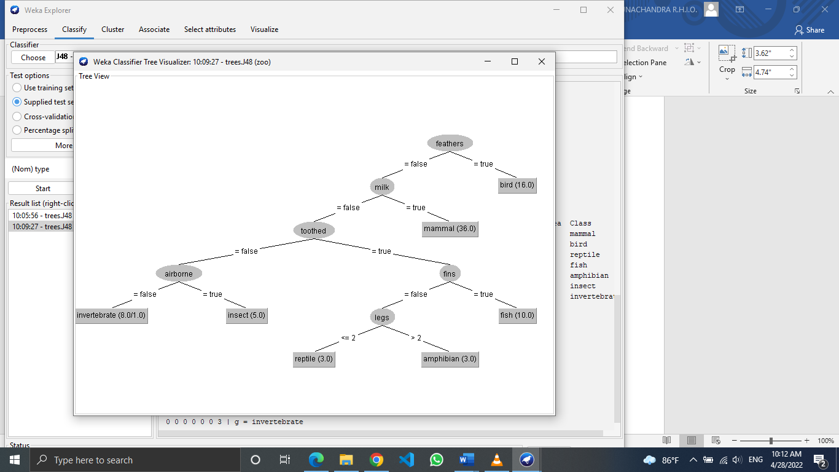

4. Output predictions

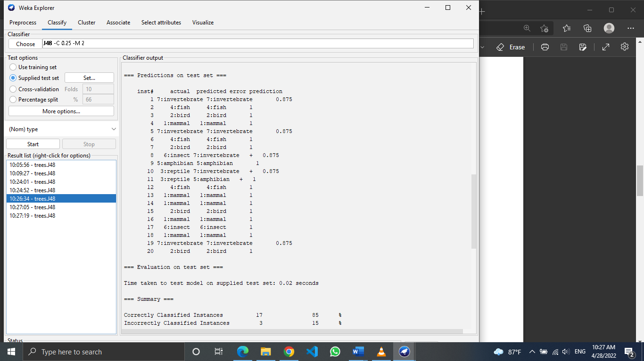

5. Re-evaluation

There is no difference in previous output and re-evaluated output. But if there is a large data set it might show a difference.

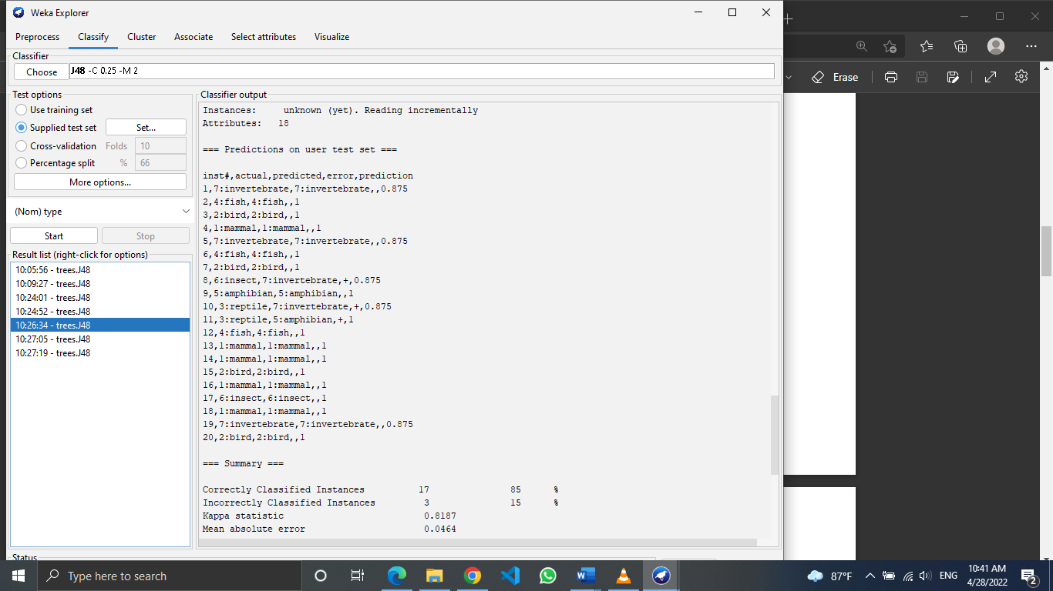

Exercise:

1.Training set



2.Test set



3.The percentage of correctly classified instances is higher in training data set than the test data set. This might be because of the number of total instances is comparably higher in the training set.

4. No result was obtained. Since the attributes are not the same in the test and train data sets it might be not able to perform the prediction using C4.5 model.

